CCDSALG Term 3, AY 2025 – 2026
MCO1 DOCUMENTATION – Convex Hull (Application of Stack Data Structure & Sorting Algorithms)

I. DECLARATION OF INTELLECTUAL HONESTY & ETHICAL USE OF GENERATIVE AI

- We declare that the project we are submitting is the product of our own work augmented with responsible and ethical use of generative AI as encoded in Table 1 and Table 2 below.
- We declare that all AI-assisted contributions have been critically examined by our group. We acknowledge the limitations of Generative AI systems, including possible errors or biases, and accept full responsibility and accountability for all contents in all our project deliverables.
- We also declare that each member COOPERATED and contributed EQUALLY to the project as detailed in Table 3 below.
- No part of our work was shared with another person outside of our group.

// Instruction #1: Encode your names, and affix your e-signature to attest to the declaration above.
LASTNAME1, FIRSTNAME1 SECTION SIGNATURE

LASTNAME2, FIRSTNAME2 SECTION SIGNATURE

LASTNAME3, FIRSTNAME3 SECTION SIGNATURE

// Instruction #2: Fill-up the column 2 of Table 1 below.
For each of the following tasks, identify the degree of AI use among the following:
• NONE - No AI was used for this task
• SCAFFOLDING - AI was used to build the foundation for this task, e.g., brainstorming, solution ideation
• REFINEMENT - AI was used to review, provide feedback, and revise outputs for this task
• GENERATION - AI was used to generate portions of the output for this task

Table 1. Responsible and Ethical Use of AI Details
TASKS | DEGREE OF AI USE & BRIEF EXPLANATION
T1: Understand the project specifications (problem) & assign responsibilities. | This is an example only; write your own actual content.  NONE - we did not use AI in understanding the problem specs.  or something like:  SCAFFOLDING - we used AI to get a more detailed explanation about the convex hull problem.
T2: Design, implement and test your stack data structure module. | This is an example only; write your own actual content.  GENERATION - we used AI to generate an initial version of the codes for the stack implementation. We carefully studied the codes and checked for correctness. We then subsequently modified the implementation of the following functions: <enumerate the functions here…>
T3: Implement and test your TWO sorting algorithms module. | Fill this up.
T4: Implement two versions of Graham’s Scan algorithm. | Fill this up.
T5: Implement two driver programs to test the two Graham’s Scan algorithm versions. | Fill this up.
T6: Black box test your Graham’s Scan Algorithm implementation. | Fill this up.
Task 7. Document your project. | This is an example only; write your own actual content.  REFINEMENT: we wrote our documentation by ourselves, and then used AI to get a review/feedback on how we can improve the document. We refined the document based on the feedback that we deemed reasonable and logical.

// Instruction #3: Fill up Table 2. List explicitly ALL AI tools that you employed, and justify their purpose/role in your project.

Table 2. List of AI Tools Used
AI TOOL USED (embed the link) | JUSTIFICATION/PURPOSE/ROLE
Tool #1 with embedded link | We used this to ….
//… add more lines as you deem necessary

// Instruction #4: Fill up columns 1 and 2 of Table 3.
Table 3. Individual Contributions to the Project
NAME | CONTRIBUTION DETAILS
LASTNAME1, FIRSTNAME1 | Encode details of your contributions for each task. Indicate your role, for example, were you the project manager, were you the (lead) programmer for a certain module, were you the (black box) tester for a certain module, which part of the documentation were you responsible for? etc… Encode NONE if you did not contribute to a particular task.  T1:  T2:  T3:  T4:  T5:  T6:  T7:
LASTNAME2, FIRSTNAME2 | T1:  T2:  T3:  T4:  T5:  T6:  T7:
LASTNAME3, FIRSTNAME3 | T1:  T2:  T3:  T4:  T5:  T6:  T7:

II. SUBMISSION CHECKLIST
// Instruction #5: Fill up Column 3 of Table 4 below.
Put a check mark as specified in the 3rd column of the table below. Please make sure that you use the same file names and that you encoded the appropriate file contents. You may create/add other source files (for example, for reading and writing data).
Table 4. File Submission Checklist
FILE | DESCRIPTION | Put a check mark ✔ below to indicate that you submitted a required file
stack.h | stack data structure header file
stack.c | stack data structure C source file
test_stack.c | driver program for the stack module
sort.h | “slow” and “fast” sorting algo header file
sort.c | “slow” and “fast” sorting algo C source file
test_sort.c | driver program for the sorting module
graham_slow.c | Graham’s Scan algorithm slow version (using the “slow” sorting algorithm)
graham_fast.c | Graham’s Scan algorithm fast version (using the “fast” sorting algorithm)
test_slow.c | drive program for the “slow” version
test_fast.c | drive program for the for the “fast” version
INPUT1.TXTto INPUT10.TXT | 10 sample input files (with increasing values of n)
OUTPUT1.TXT to OUTPUT10.TXT | 10 sample corresponding output files
GROUPNUMBER.PDF | the PDF file of this document

III. INSTRUCTIONS ON HOW TO COMPILE & RUN THE PROGRAMS
// Instruction #6: Indicate how to compile your source files, and how to RUN your exe files from the COMMAND LINE.
Examples are shown below highlighted in yellow. Replace them accordingly. Make sure that all your group members test what you typed below because I will follow them verbatim (copy/paste as is). I will initially test your solution using a sample input text file that you submitted. Thereafter, I will run it again using my own test data:

- How to compile from the command line
C:\MCO> gcc -Wall test_slow.c -o slow.exe
C:\MCO> gcc -Wall test_fast.c -o fast.exe

- How to run from command line
C:\MCO>slow
C:\MCO>fast

Next, answer the following questions:
- Is there a compilation (syntax error) in your codes? (YES or NO). ____
WARNING: the project will automatically be graded with a score of 0 if there is syntax error in any of the submitted source code files. Please make sure that your submission does not have a syntax error.

- Is there any compilation warning in your codes? (YES or NO) _____
WARNING: there will be a 1 point deduction for every unique compiler warning. Please make sure that your submission does not have a compiler warning.

IV. DISCLOSURE OF ERROR(S)
// Instruction #7: Disclose IN DETAIL what is/are NOT working correctly in your solution.
Please be honest about this. NON-DISCLOSURE will result in severe point deduction! Explain briefly the reason why your group was not able to make it work.

The following are NOT working (buggy):
a.
b.

We were not able to make them work because:
a.
b.

V. TEST RESULTS
// Instruction #8: Fill up Table 5 below.
Based on the exhaustive empirical testing that you did, fill-up the Comparison Table below that shows the performance between the “slow” version versus the “fast” version. Test for 10 different values of n, starting with n = 2^6 = 64 points.

Table 5. Performance Comparison Between “Slow” and “Fast” Versions
Test Case # | n (input size) | “Slow” version  execution time in ms | “Fast” version  execution time in ms
1 | 2^6 = 64
2 | 2^7
3 | 2^8
4 | 2^9
5 | 2^10
6 | 2^11
7 | 2^12
8 | 2^13
9 | 2^14
10 | 2^15 = 32768

NOTE: Make sure that you fill-up the table properly. It contributes 4 out of 15 points for the Documentation.

// Instruction #9: Provide a graph showing a visual comparison of the “slow” and “fast” versions.
Create a graph (for example using Excel) based on the Comparison Table that you filled-up above. The x-axis should be the values of n and the y axis should be the execution time in milliseconds (ms). There should be two line graphs superimposed on the same xy axes, one for the “slow” and the other for the “fast”. DO NOT SUBMIT TWO separate graphs. Replace the image below with your own.
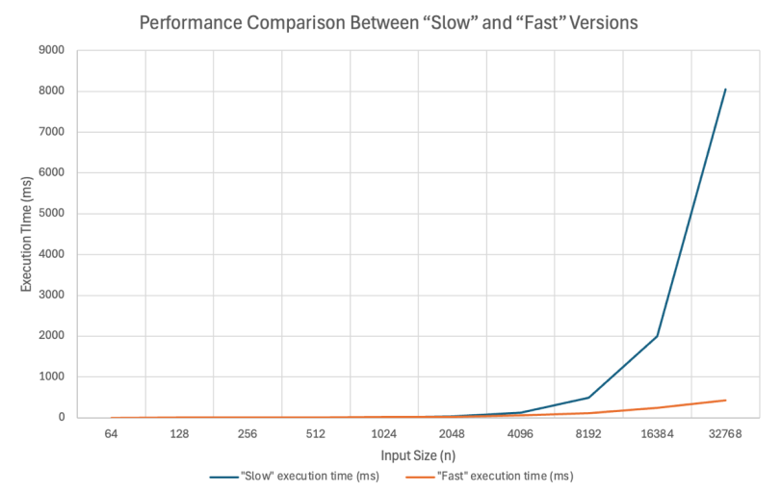

NOTE: Make sure that you provide a graph based on your comparison table data above. It contributes 4 out of 15 points for the Documentation.

VI. ANALYSIS OF RESULTS
// Instruction #10: Compare and analyze the growth rate behaviors of the “slow” and “fast” versions based on the Comparison Table and the graphs above.

Answer the following questions:
a. What do you think is the growth rate behavior of the “slow” version?
<your answer>

b. What do you think is the growth rate behavior of the “fast” version?
<your answer>

c. What do you think is/are the factor/s that make the “fast” version compute the results faster than the “slow” version?
<your answer>

NOTE: Make sure that you provide cohesive answers to the three questions above. This part contributes 4 out of 15 points for the Documentation.

VII. SELF-EVALUATION
// Instruction #11: Fill-up Table 6 below.
Refer to the rubric in the project specs. It is suggested that you do an individual self-assessment first. Thereafter, compute the average evaluation for your group, and encode it below.

Table 6. Self-Evaluation
REQUIREMENT | AVE. OF SELF-ASSESSMENT
1. Stack | ____ (max. 20 points)
2. Sorting algorithms | ____ (max. 10 points)
3. Graham’s Scan algorithm | ____ (max. 40 points)
4. Project Documentation and Analysis | ____ (max. 15 points)
5. Compliance with Instructions | ____ (max. 5 points)
TOTAL SCORE | ___ over 90.

Note that the remaining 10 points (over 100) will come from the project demo.

NOTE: The evaluation that the instructor will give is not necessarily going to be the same as what you indicated above. The self-assessment is for your own reference only…

– The End –

サルバド-ル・フロランテ

